**D.3.4) Transportation Subsystem**

The transportation subsystem is a complementary part to the Li-Fi communication in order to achieve image transmission between two end terminals where a vehicle transports the data between transmitter and receiver terminals. As the vehicle receives the data from the transmitting terminal with the methods explained in the communication subsystem description it transports the data towards the second terminal, while moving on physically guided tracks, to the location where again Li-Fi communication would take place. When the transported data is transferred to the receiving terminal the vehicle is required to go back to the transmitting terminal to receive the new packet.

The whole image transmission process is required to be done under 2 minutes in which both VLC communication and data transportation by the vehicle must be handled while the distance between the two end terminals are varying up to 1.5 meters. The maximum amount of data that the vehicle can carry is limited to 10kB while the vehicle is expected to do at least 5 laps, going back and forth between the terminals on physically guided tracks, for the transportation of the whole image. By considering the number of minimum laps and the time limitations we have stated in our conceptual design report that the average velocity of the vehicle must be at least 25cm/s for the maximum distance case when the two terminals are 1.5 meters away from each other. In addition to these, the vehicle must come to stop at least 5cm away from the terminals which requires a sensor fed controller considering that the distance between the terminals is variable.

To accomplish all these tasks the design of this subsystem can be divided into three parts which are the control loop design, physical structure of the vehicle and the design of the physically guided tracks that the vehicle will travel on.

***Control of the Vehicle:***

In order to control the vehicle, we designed a closed loop controller where the distance of the vehicle to the terminals measured by an ultrasound sensor is used as the feedback. We are using four DC motors as the actuators of our vehicle. We are using a L298N motor driver that is simply a double H-Bridge driver circuitry which enable turning the motors in both directions by changing the polarity of the applied voltage using switches as shown in Figure xxxx. We have tested the L298N motor driver with our vehicle and ensured that our vehicle can go back and forth in both ways under the control of an Arduino UNO microcontroller.

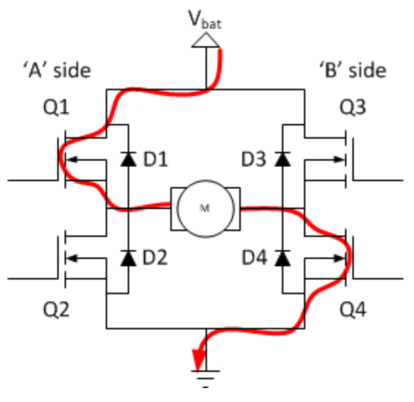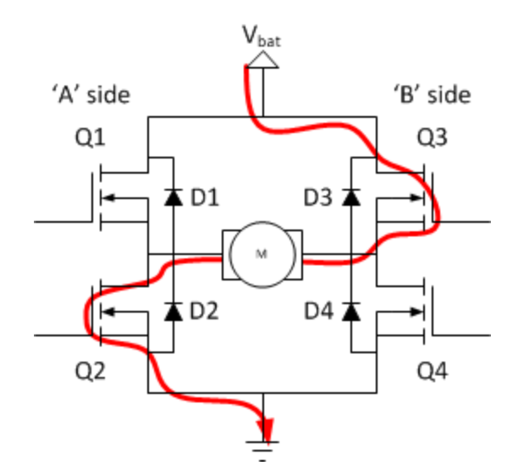

Figure 1. H-Bridge circuitry which enables the rotation of DC motors in both directions

The vehicle would understand that the data is transmitted to its receiver as the specific end signal is received and then it would rush towards the receiving station. At this point, we were planning to increase the speed of the motors gradually but in our tests we observed that applying full voltage of 5V from the beginning doesn’t cause any problems. Doing so does not cause the motors to draw more current than the L298N can handle and mechanically the vehicle is able to withstand to that instant acceleration which makes this method better as we want to be as fast as possible. Throughout the transportation, the controller would get the distance data of the vehicle and as the distance gets smaller than a certain threshold the vehicle starts to brake as we have proposed earlier. The earlier proposed method of deceleration was again to decrease the duty cycle of the PWM signals that are feeding the enable pins of the motor driver. Instead, we learned a new method of braking that can be implemented without varying the duty cycles of the enable pins. By closing the switches labeled as Q1 and Q3 in Figurexxx and opening Q2 and Q4, the stored current inside the DC motor due to its inductive nature is dissipated as heat as it flows through the resistance of the inductor and the on-state resistance of the two FETs. This method enables the slow decay of the stored current which actually results in the quick stopping of the motors. As this method is still causing gradual deceleration rather than locking of the motors we observed in our test that it enables us a smooth enough operation.

By obtaining the distance measurements from the ultrasound sensors at both ends of the car we would apply such a closed loop control of the vehicle where are using kind of an ON/OFF control method where the driver puts the vehicle either in full-gas or in braking mode of operation.

As an alternative method of sensing the distance we have proposed to use an IMU for the case that we are not satisfied with the performance of the ultrasound sensors. However, we found the performance of the ultrasound sensors satisfactory inside range that we are interested in. During ou tests…